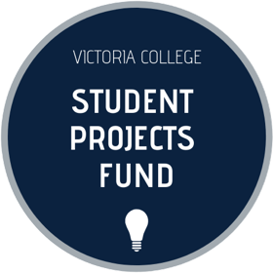

Student Projects Fund 2019-2020
Committee Application

Student Projects Committee members select the projects that will receive funding from the Student Projects Fund. They also help with the creation of promotional materials. Members are expected to attend bi-weekly meetings and review applications prior to attending.

Positions available:

- Two commuter students
- One residence student
- One club representatives
- One levy representative

Portfolios available:
      - Deputy Chairperson – Will assist the chairperson in handling grants, expenses, and will be responsible for assisting the Chairperson in representing Student Projects to VUSAC and the VCU.
      - Secretary – Will assist the chairperson in taking minutes, organizational tasks, chairing meetings.
      - Communications – Will assist the chairperson in updating social media, websites, and any graphic design.

Meetings will occur bi-weekly and will be scheduled pending the availability of the Chairperson and successful committee applicants.

The first meeting will take place on October 12, 2018.

Any Questions? Please contact Leora Nash at studentprojects@vusac.ca or visit the website at www.vicstudentprojects.com

Please submit this completed form to Leora Nash at studentprojects@vusac.ca
by 11:59 PM on Friday, October 11th.
Please circle which group you are applying as (select one):

Levy Representative or Club Representative or Individual

Name: | Year of Study:
Email: | Student Number:
Residence or Commuter: | Phone Number:

Please answer the following questions:

- Why would you like to be a member of the Student Projects Committee?
- What skills and experiences would you bring to your role as a Committee member?
- How would you promote the Student Projects Fund to Vic students?

- Are you interested in taking on a portfolio (Deputy Chairperson, Secretary, Communications) within the Student Projects committee? If so, what experiences has prepared you for this role?
- What other commitments do you have throughout the 2019-2020 academic year?
- Have you ever been a member of the Student Projects Committee or Advisory Board?

Please submit this completed form to Leora Nash at studentprojects@vusac.ca
by 11:59 PM on Friday, October 11th.

